Case 4-Eur-Cameos-Grand Tour

Bartolomeo Paoletti. Containing 24 plaster cameos with handwritten numbered descriptions. The present example dates from the lifetime of Bartolomeo, however, as evidenced by the following inscription: Si fanno in Roma da Bartolomeo Paoletti, e Pietro figlio, dimoranti di Studio in Piazza di Spagna num° 49.

Making casts from engraved gems, or cameos, was a common practice from ancient times, and was particularly popular among Roman connoisseurs of the 18th century. When such plaster casts became popular souvenirs for Grand Tour travelers in the early 19th century, several shops opened which specialized in them. These souvenir casts not only represented carved gems, but also contemporary and ancient sculptures and monuments, and were often mounted in faux book bindings. Bartolomeo Paoletti (1757-1834) and his son, Pietro (1801-1847) were some of the most prolific. The Paolettis, whose studio was located on the Piazza di Spagna in Rome until 1847, enjoyed a stellar reputation, and counted among their clients Catherine the Great of Russia and Ferdinand III, Grand Duke of Tuscany. The firm continued to do business after the death of Pietro until at least 1865.

US $1,800.00Approximately **EUR 1,693.40**

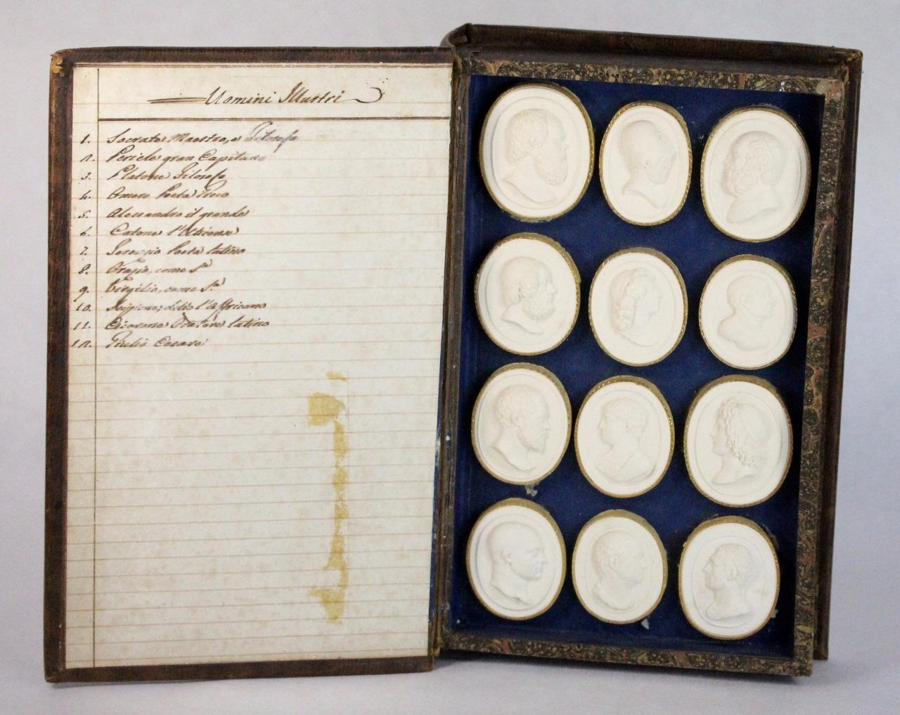 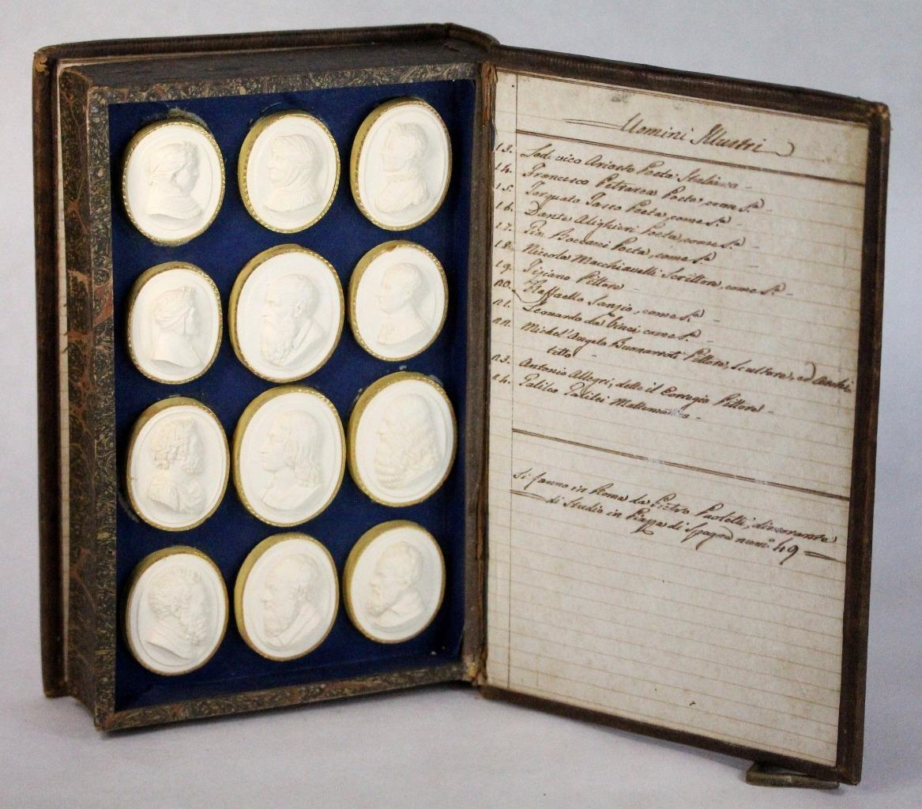

COLLECTION OF ANTIQUE ITALY GRAND TOUR OF PLASTER INTAGLIO SEALS ITALIA RARE !!

This is a beautiful Italian Grand Tour Plaster Intaglio collection. It is very old and the plaster has held up quite well. Each piece has a very small and finely detailed scene within. There are a few with damage on them unfortunately, see photos. This is an original item !! It would make an excellent addition to any collection!

Please see photos for item condition and description.

US $1,199.00

Approximately **EUR 1,127.99**

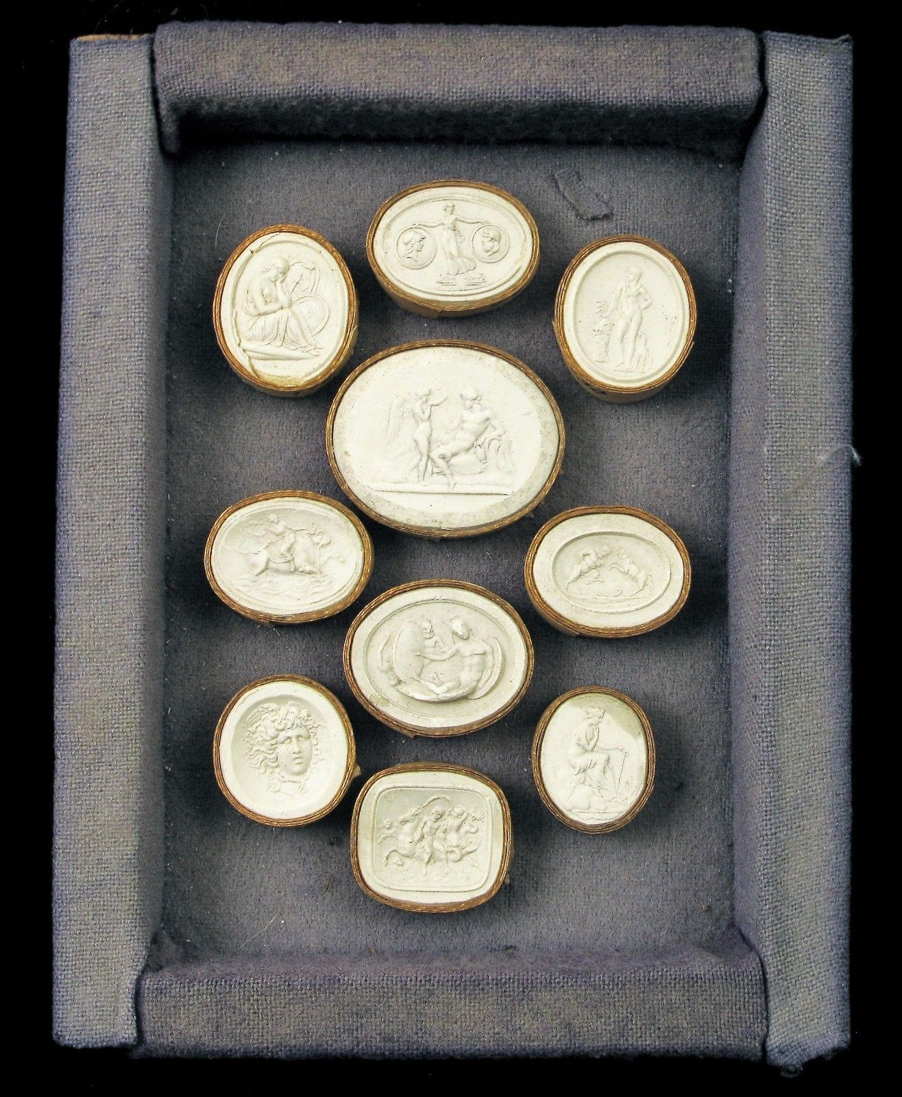

=========================================================================== 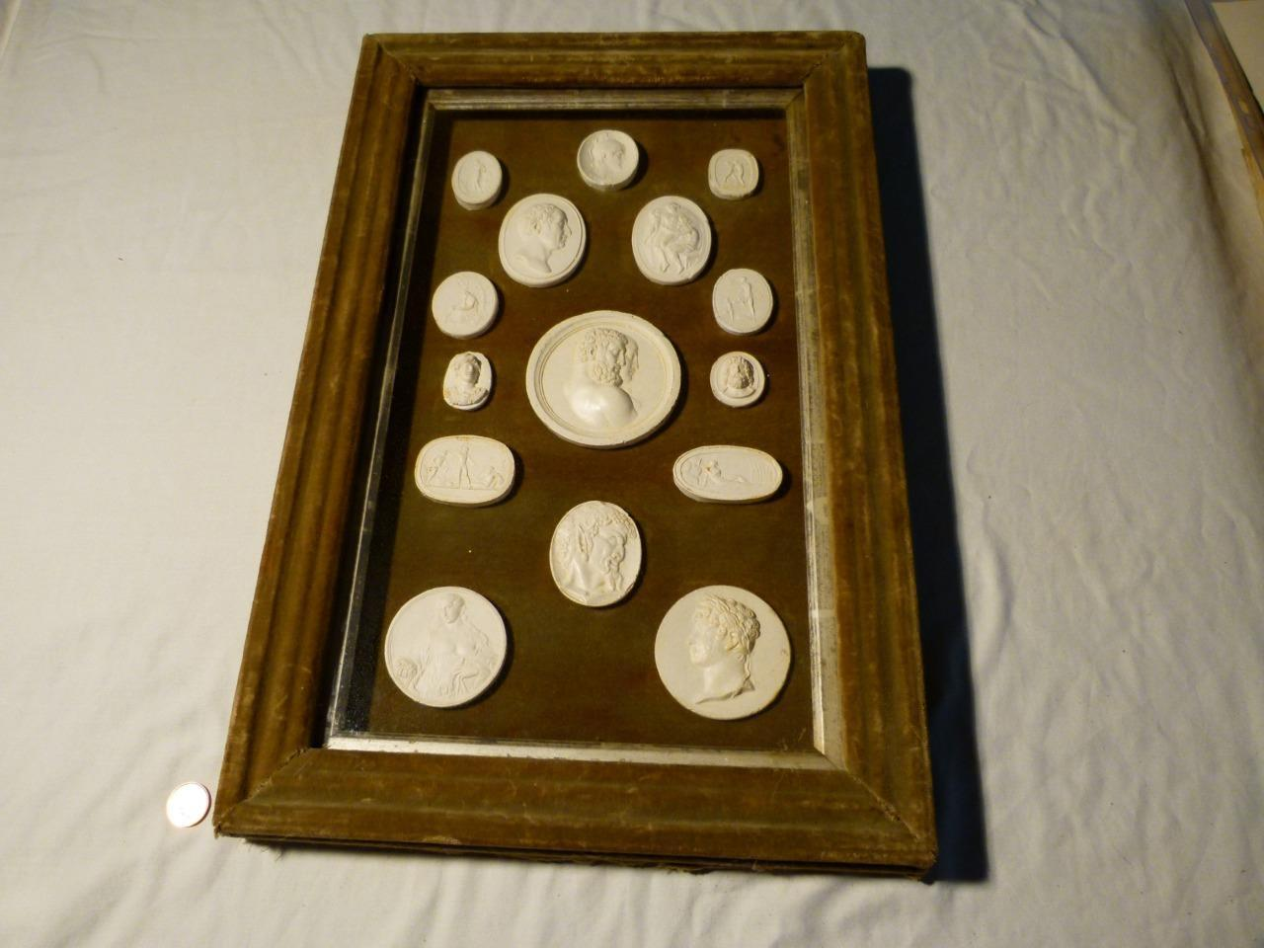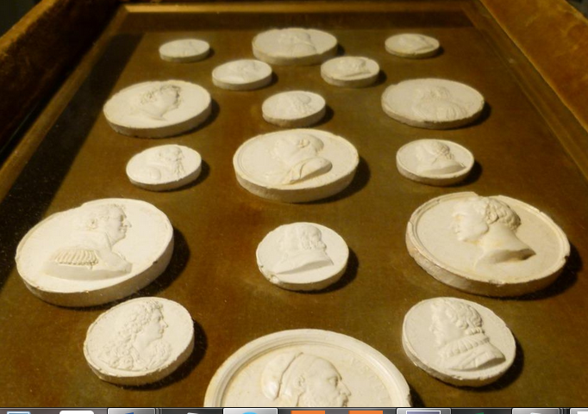

**Here are two framed items.. both from the same deceased grand house..a country gentleman estate.  
As you can see the frames are wood covered in a pale green velvet material with glass in front.. and an inner pale gilt - silver frame... the backing is green velvet too.. the frames are deep.. abit like shadow boxes...they have a yellow golden material on their backs and a large suspension loop to be hung by.  
Both frames are slightly differant.. so they arre NOT a pair as such.... I would imagine the home they are from would have had many more down a corridor or a library wall as furnishings.  
These plaster mouldings were very popular during the GRAND TOUR period.. Georgian - Victorian times... when the aristocracy went to Italy and similar places and bpught these mouldings.. it became quite a pastime for them... some even moulded their own collection whilst on route taking mouldings of seals and medals and tassies.  
These two frames have a mixture of TASSIE - MEDALLIONS..... some of the medals have wording legend... so you could quite easy work out the LATEST item within the frames.  
The tassies are usually GREEK or ROMAN intaglio seals from rings etc.. and they were reproduced larger... you will often find these actual size for sale.  
As well as that they reproduced cameos and larger plaques etc... these tend to be large plaster mouldings.  
They are good deep mouldings ...some of the edge plaster is nibbled and damaged .. as they do NOT have the red or gold stiff card surrounds as found on the smaller tassies.  
The frame with the fewest in has a FAUN ...pointy eared fellow with a beard with Grapes on his head as hair... quite often mythology and mythical creatures pictured....so one group there are 15 mouldings in it.... the largest moulding is approx 3 and half inch dia ... and smallest is 1 inch wide......the frame is approx 19 inch x 12 and half inch x 1 and half inch deep.  
The other frame has mainly MEDALS in it.. with legend some of them ...19 in this one..FAMOUS people ... again the edges have chips and knocks..largest moulding is 2 and half inch dia ... smallest is 1 and a quarter inch dia.....this frame is 19 inch x 13 inch x 2 and a half inch deep.  
These are ANTIQUE items... not modern reproductions....I have not been inside the frames.**

£1,950.00Approximately **EUR 2,280.58**

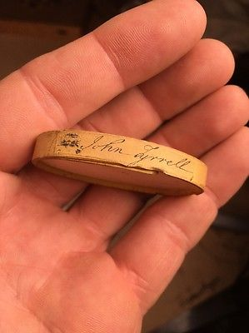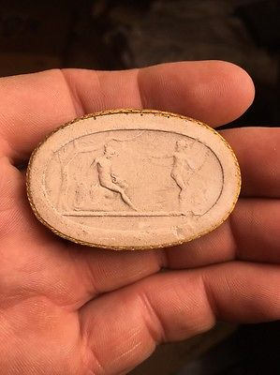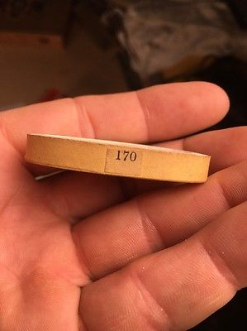

**Grand Tour Cameo John Tyrrell Roman #170**

**CAD $59.00** Buy It Now 13d, CAD $12.45